**Visual Guide:**

**School of Scottish Studies Archives & Library**

## Building Location

The School of Scottish Studies Archives & Library is on George Square at building number 29. You can view the location on the campus map:

[Visit the Campus Map on the University Website](https://www.ed.ac.uk/information-services/library-museum-gallery/using-library/lib-locate/main-lib)

|  |
| --- |
| C:\Users\ncolema2\AppData\Local\Microsoft\Windows\INetCache\Content.Word\20230710_143230.jpg   The building is at the end corner of George Square nearest to the Main Library.  Image description: The front entrance to the Main Library. It is a grey building with a large stone sign that says ‘Library’ in front of the building. To the right of the image is the SSSA building in the distance. |
| This image is of the School of Scottish Studies Archives & Library building at 29 George Square.  Image description: a tall brown building with four levels. There is a black door with steps in front of the door. There is a blue sign to the left of the door. There is an accessible open lift to the right of the door. There is a black railing in front of the entrance walkway to the building, that goes along the right of the building.    There is a railing wall in front of the building. To reach the entrance of number 29, go to the end of the railing wall on the right of the building.  Image description: A row of brown buildings next to 29 George square showing the pavement and railing to the walkway.    Follow the path between the railing wall and the buildings to the end to reach number 29.  Image description: This is the walkway along the buildings to reach the steps and accessible lift at the entry of 29 George Square. |

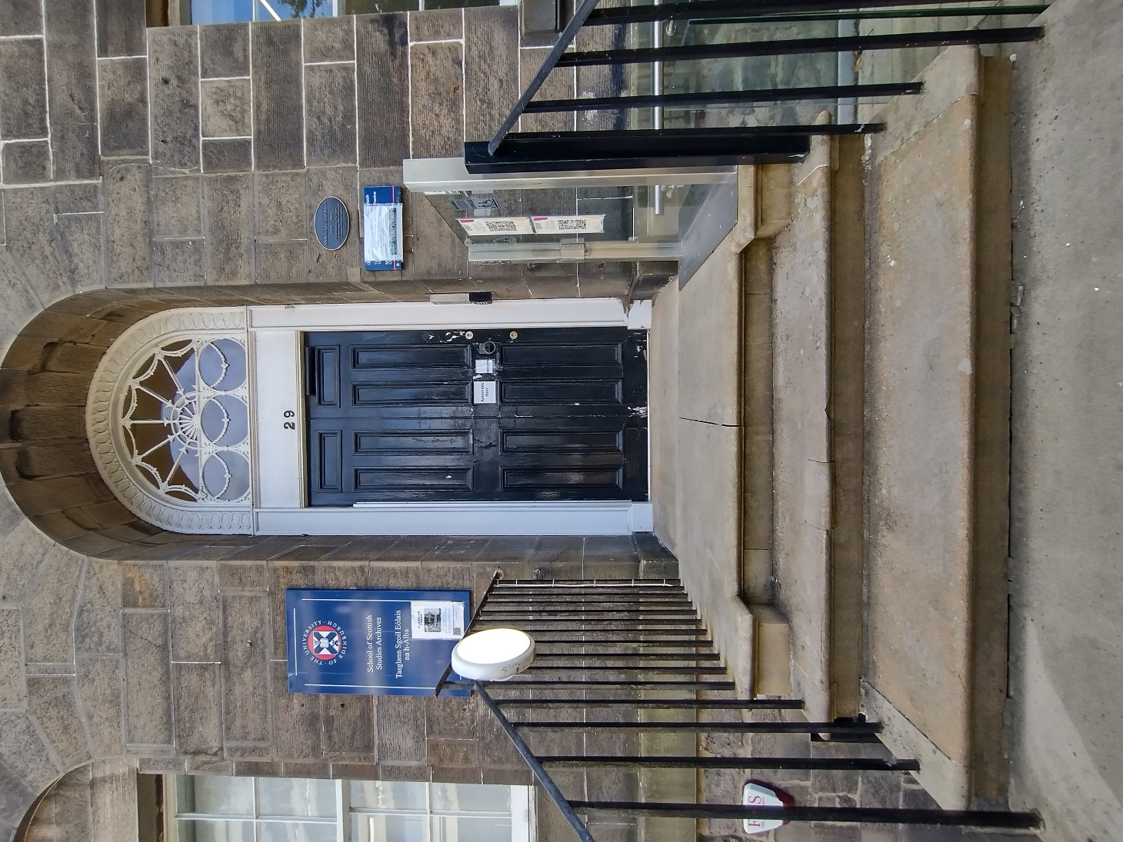

Image Description: A view of the steps to the front door entrance to 29 George Square. There are four steps with railings on each side, leading to the small platform entrance to the door. To the right is the higher glass gate of the accessible lift.

|  |
| --- |
| There is an accessible lift to the main door of the building. There is a button system to the right of the gate. To use the lift, push the middle button to open the glass lift gate and enter the lift. To operate the lift, the glass gate must be closed.  Image description: The entrance steps and accessible lift leading to the front door of 29 George Square.  Press the top button to go all the way up. This can be slow and makes a little bit of noise. The exit gate is to the left. You will then be outside the front door.  Please be mindful of the stairs to the left side of the lift. If you need assistance with the lift, please inform a member of staff before your visit so they can be available to operate it and open the front door for you.  Image description: The accessible lift. It is a glass gated door with a separate control panel to the right and slightly in front of the lift. It has an up, open gate, and down keys. |

|  |
| --- |
| Entry into the building |

|  |
| --- |
| When calling the intercom, state your name and reason for visiting. For example:  Hello, my name is \_\_\_\_\_ and I am here for a reading room appointment.  The member of staff will then respond that they will open the door for you, and invite you to come in to the building.  Image description: a close-up image of the black front door and the intercom on the right-hand side within the archway. It is a small grey box with the call button on the bottom right. Underneath the intercom is a black card keypad with 12 buttons for the use of staff. |
| As you enter the building, there will be Library book barriers to pass through. These do not have a gate or require a card for entry and are for detection of Library barcoded material. It may beep as you go through.  Image description: The open front door and foyer of the building. There are white book barriers with wall shelving to the right. Past the barriers, there are lockers to the right and the entry to the search room on the left. Ahead of the lockers and door entry to the search room is an archway. The accessible toilets are to instant left behind the archway. Further on are steps leading downstairs and upstairs to staff-only areas.  When you are past the barriers, there are lockers on the right for you to put your belongings in. Lockers do not require a token. There will be a key inside the locker to keep for the duration of your visit.  The search room is through the doorway to the left.  Behind the archway and to the left is the entry to the accessible toilet.  The stairs going up lead to the Library. This will be the door straight ahead on the 1st floor.  Image description: The open front door and foyer of the building. There are white book barriers with wall shelving to the right. Past the barriers, there are lockers to the right and the entry to the search room on the left. Ahead of the lockers and door entry to the search room is an archway. The accessible toilets are to instant left behind the archway. Further on are steps leading downstairs and upstairs to staff-only areas. |

|  |
| --- |
| Appointment Information |

|  |
| --- |
| Once you are through the Library book barriers, a member of staff will come out from the search room door to the left to greet you.  Staff will then explain the search room rules. These are:   * No bags and coats allowed. * No food and drink allowed. * No pens allowed, only pencils. * You can bring in notebooks, laptops, headphones, and any notetaking equipment or assistive tech and equipment you may have.   You are welcome to enter the search room when you are ready. Do feel free to use the accessible toilets or go to your belongings if needed at any point during your visit.  Image description: A closer image of the door leading to the search room on the left of the foyer, with the archway and stairs ahead of this. The image on the next page is of the view from the door into the search room. You can see the desks to the left of the room and the shelving to the right of the half of the room, and shelving and windows at the back wall. |

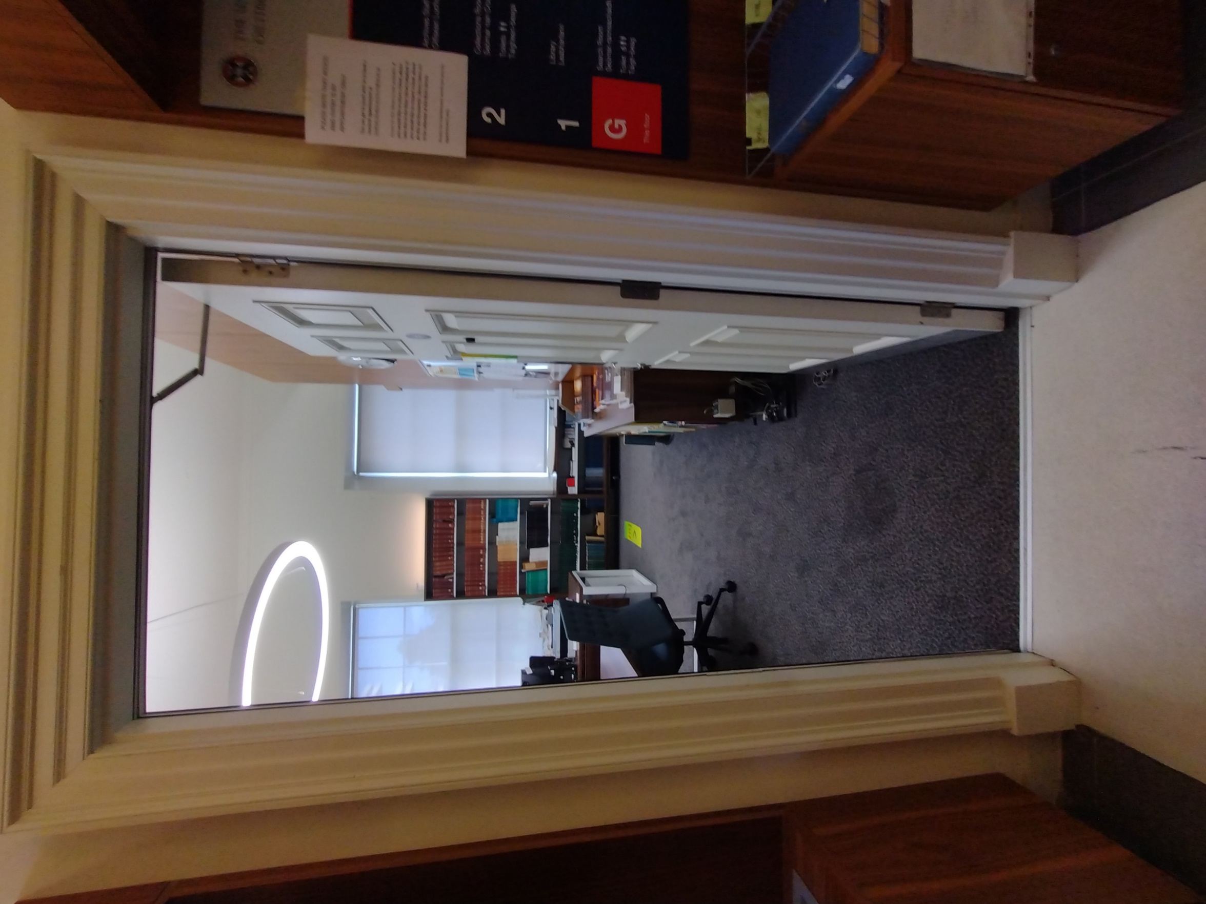

|  |
| --- |
| The Search Room |

|  |
| --- |
| When you enter the search room, the member of staff will give you an induction to the research resources available and how to use them.  To the left of the room is a manuscript desk with a dual screen computer for use. The desk at the back left is for the member of staff invigilating the appointment.  The back right of the room will take you to further computer desks and the main research resources for use during your visit.  In the pathway to the computers and archival resources, there are journals on the shelving to your left, and a filing cabinet on the right. The filing cabinet contains photographic material, which you are welcome to browse. However, please keep material in order. There is a subject guide for photographic material on top of the cabinets.    Past the pathway, there are computer desks and research resources.  The shelving on the left wall contains register books for sound material, transcript books for sound material, and copies of manuscripts.  The small cabinets at the back contain index cards for searching collections and references.  Above the cabinets are shelving containing small green books for searching Scots Songs, Gaelic Songs, and Piping Material.  The member of staff can log you on to the computer if needed. There will also be public login information on a piece of card on the desk by each computer.  Once the induction is done, the member of staff will be mainly be sat at the staff desk in the back left corner of the room to continue to facilitate the appointment. You are welcome to ask questions or ask for assistance at any point. |

|  |
| --- |
| Leaving the building |

|  |
| --- |
| Collect your belongings from the locker.  Go through the Library gate barriers.  There will be a green button to your left. Press the button to open the front door. Be careful as the door can open quite wide. You may need to move back.  Exit the building.  The gate for the lift will be on the left side. Follow the procedure for operating the lift. If the gate does not open, you may need to bring the lift up. Press and hold the top button to bring the lift up. Press the middle button to open the lift gate.  Enter the lift and close the gate. Press and hold the bottom button to make the lift go down. Once the lift is all the way down, press the middle button to open the other glass gate.  Do feel free to ask for assistance if required.  Follow the path between the railings and the buildings to the left to exit to the pavement. |